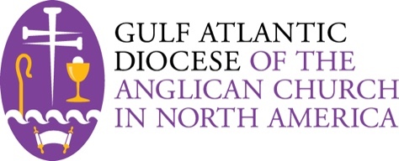

Aspirant Personal Information

- Aspirants in the Gulf Atlantic Diocese Ordination Preparation Process, whether aspiring to the Diaconate or the Priesthood, send the following personal information to the Canon for Ordination Preparation via the Diocesan office. All records submitted will be kept confidential and will reside in the Diocesan Office.

PLEASE SUBMIT THIS FORM PRIOR TO COMPLETING ALL THE OTHER ASPIRANT WORK.

These are expandle boxes for you to fill in your information. If you need more lines for a given answer the Table will automatically expand.

Date
Name
Address
Phone (home, cell, work)
Email
Date of Birth
Marital Status
Number of Marriages
Dates of Marriage(s)
Spouses full name and birthdate
Names and birthdates of children
Diocese
Present Parish Affiliation
Location
Rector/ Vicar
How long?
Prior Parish Affiliations
Baptism Church Name
Location
Baptism date

Confirmation Church Name
Location
Confirmation Date
Confirming Bishop
Diocese
Have you previously applied for ordination in this or any other denomination?
When?
Where?
If YES, you must request that all documentation be sent directly to the Canon for Ordination
Are you ordained in any other denomination?
If YES,
Which denomination?
For what order?
When?
Date of Introductory Meeting with the bishop

Please submit this form by mail:

Harris Willman, Diocesan Administrator
Gulf Atlantic Diocese
4815-200 Executive Park Ct. Ste. 201
Jacksonville, FL 32216

Or digital copies by email:

The Rev. Canon Mark DiCristina 850-450-3832
mdicristina@gulfatlanticdioces.org
Harris Willman, Diocesan Administrator 904-465-7901
hwillman@gulfatlanticdiocese.org

